32nd Tennessee References in the Confederate Veteran

II, 5, May 1894, p. 132:

Commendable zeal is exercised by the people at Calhoun, Ga., in caring for the Resaca Confederate dead buried near there. That is a cemetery in which Southerners from many sections should be interested. Mr. J. O. Middleton sends the following list of some of the Tennesseans buried there, with their company and regiment: J. H. Waddy, 32d; F. Russell, Co. A, and J. A. Gilmore, Company B, 45th; J. W. Lester, Co. C., 29th; J. H. Savage, 20th; A. Thelton, 18th; A. V. Simonton, and three unknown soldiers belonging to [the] 9th; J. Lipsheets, Co. G, John Ingles, Co. D, and J. W. Rathers, Co. C, 8th.
Give something to this worthy cause, no matter how small the amount. J. O. M.

II, 6, June 1894, p. 164:

CONFEDERATES CAPTURED AT FORT DONELSON.

Capt. J. H. George, Howell, Tenn., writes: My dear old comrade in arms: Years have passed since we last viewed each other's faces. But when the VETERAN puts in its appearance it is like a visit from some old friend who wore the gray. Then we sit down for an enjoyable chat of trials and deeds of valor in days gone by. How vividly are brought to memory scenes and incidents of the camp and field while reviewing the pages of this monthly visitor. May it still increase and continue to grow better and better.
I enclose the names of the regiments and commanders, as I remember them, that were captured at Fort Donelson, February 16, 1862: Tennessee regiments—3d, Col. Brown; 10th, Col. Heiman; 18th, Col. Palmer; 26th, Col. Lillard; 30th, Col. Head; 32d, Col. Cook; 41st, Col. Farquharson; 42d, Col. Quarles; 49th, Col. Bailey; 50th, Col. Sugg; 51st, Col. Browder; 52d, Col. Voo[r]hies; 53d, Col. Abernathy; Kentucky regiments—2d, Col. Hanson; 8th. Mississippi regiments—1st, 3d, 4th; 14th, Col. Baldwin; 20th, 26th. Alabama regiment—8th. This last was commanded by Col. Gregg, afterward General, who was killed in Virginia.

IV, 5, May 1896, p. 165:

CAPTAIN McFERRIN TREASURED HIS "OLD GRAY COAT."—An interesting and well-written story comes from Lewisburg, Tenn., in which the "old gray coat" is conspicuous. It tells that James A. McFerrin, who belonged to the Thirty-second Tennessee Infantry, while in the hospital at Columbus, Ga., to recover from a wound caused by the explosion of a shell, had made and presented to him a uniform of gray jeans by Miss Glenn of that place. Captain McFerrin returned to his wife and children after the surrender. The Federal soldiers cut the three bars from the collar of his coat while passing through Huntsville, Ala.
A baby girl was named for Miss Glenn afterward. Two years ago Mrs. McFerrin died and recently Miss Glenn because Mrs. McFerrin. The groom was married in the gray coat that Miss Glenn made for him thirty-two years before. The ceremony was performed by Rev. J. R. Harris, chaplain of the J. H. Lewis Bivouac [of the United Confederate Veterans].

IV, 7, July 1896, p. 217-218:

EXPERIENCE OF ESCAPING PRISON.

Miss Susie Gentry, Franklin, Tenn.:
Thomas P. Owen, of Col. Ed. Cook's Thirty-second Regiment of Tennessee [volunteers], was detailed by Col. Cook, when at Lookout Mountain, Nov. 23, 1863, to go after his horse, which had been shot in the nose, and was at a farm some distance away. It was the day of [the] Missionary Ridge battle. While Owen was on his mission he encountered some Yankee cavalry, who gave chase, and captured him and a courier between Rives Station and [the] Tennessee River. They were taken, with other prisoners, to Cleveland, Tenn., where they were told to "jump upon any horses" they could. Owen got an old gray, and while riding to Chattanooga, was ordered by an officer to dismount that a sick soldier might ride. He refused to obey. Again during the journey he was told to get down, and the officer said: "If I have to tell you again, I'll shoot you." Owen dismounted, and walked for some time, when he got "very sick," and another fellow had to walk. They had to foot it from Chattanooga to Bridgeport [Alabama], where they were put on cars for the Maxwell House Prison, at Nashville. After a few days, Owen and other prisoners were marched down to the Louisville depot to be sent North. He had determined to escape if possible, so [he] watched for his opportunity. While at the depot he saw that the guard was not watching him, and stepped across to the sidewalk, where a large party of citizens were seeing the prisoners off, and was soon lost in the crowd. However, a negro boy saw him, and called the guard's attention, and he was soon caught, when two Dutch guards made him "double quick" to the Maxwell House. Still he never gave up the idea of escape. About noon that day volunteers were asked for to carry water to the prisoners. Owen quickly presented himself (thinking the pump was somewhere outside); but, alas! he was shown a hydrant in the hotel court, where he and another pumped and carried tubs of water to the fourth and fifth stories until about twelve o'clock at night. Having now fully determined to escape, he tore up his blankets and coverlet, and made them into a rope, which he intended to suspend from a second-story window. He went down to fix his "ladder," and found the second story to be used as a dormitory. He noiselessly stepped over the men in making his way to a window, when a burly "six-footer" arose, and said: "What in the – are you doing here?" Getting ready to steal? Owen took his canteen, and said: "If you come a foot nearer, I will bust your head for you!" The "six-footer" thought discretion [was] the better part of valor, and laid down; but Owen did not get to the window that night.
About a week after this experience Owen was of another detachment of prisoners taken to the Louisville depot for Northern transportation. His "break for liberty" this third time was a charm, for he did escape. While at the depot he got out of sight of the guard. Finding three citizens leaning against a freight car, he also rested himself, and saw the prisoners put aboard. When the train pulled out, he walked back to the Square with the citizens, but did not talk for fear he would commit himself. It was December 7th [1863], and very cold. He went in the direction of the Franklin Pike. After going some distance, he struck a field of weeds higher than his head, and was making through it, when he saw near him a picket's fire behind a pile of rock[s]. He quickly dropped, and grunted like a hog, when the picket exclaimed: "You fool you! Don't you know we would ruther kill a horg now than a man?" Owen thought it time for him to "git;" so he moved away as rapidly as possible a la snake. When he had gotten somewhere in the vicinity of Fort Negley, between the pike and railroad, he again came upon a picket behind a stump. "Who comes there?" was heard by Owen, who answered: "A citizen." "Advance, and give the countersign," said the picket. "I haven't it," replied Owen: "I only started to the tollgate for a few eggs; but I believe I am about half-way lost, it's so dark." "Come up here, and I'll take you to my lieutenant," said the picket. Owen did not relish this, but put on a brave front and marched up to the fire, where he sized up his man and jumped at him, took his gun from the Dutchman, and fairly flew into the darkness, leaving "mind frendt" yelling at the top of his voice: "He's got mine gunt! he's got mine gunt!" As Owen ran, he heard the "long roll" beat and the firing of the pickets. He continued to run with the gun until he fell in a ditch so deep that the back of his neck rested on the bank, and he thought his neck was broken. He finally scrambled out, and ran on, but dropped the gun. He stopped to drink at a branch, and thought all the Yankee cavalry was after him. It proved [to be] the beating of his [own] heart. He is now an honored citizen of this town.

V, 2, February 1897, p. 81:

Ben F. Loftin, who gave a leg for the Confederacy, writes, Nashville, Tenn., January 27 [1897]: The communication of Comrade J. M. Lynn, of Crystal Falls, Tex., and this very cold weather remind me forcibly of the scenes that transpired around Fort Donelson, February 1862. My Regiment (the Thirty-second Tennessee) supported Graves' Battery on the right, the left of the regiment being in the ditches under the guns. After completing our breastworks, I kneeled down in the ditch, with my [head] resting against a wheel of Graves' rifle[d gun], to take a nap. I had slept long enough for my clothes to freeze to the ground, when the cannon was discharged at a sharpshooter. I jumped up, minus part of my pants, wondering what was the matter. The boys had the laugh on me. Pants were scarce; after dark I drew another pair, but don't tell how I got them.

VI, 3, March 1898, p. 143:

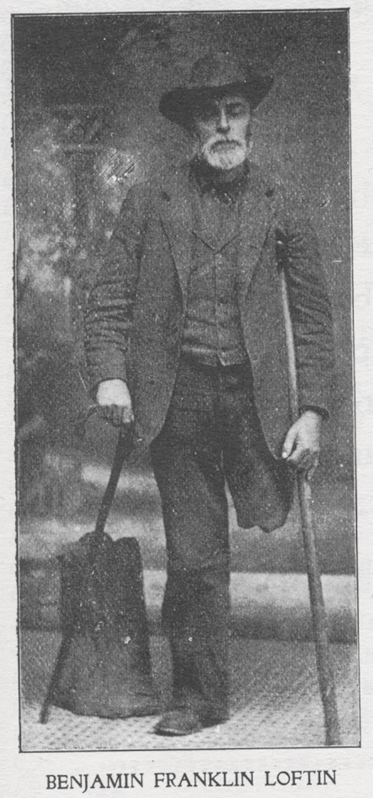
BENJAMIN FRANKLIN LOFTIN

Enlisted in September 1861, in Company D, Thirty-second Tennessee Regiment, at the age of fifteen years. He went from the battle of Fort Donelson with his regiment to the battle of Chickamauga, where he lost his leg. Was paroled with Starnes' Cavalry at Washington, Ga., May 5, 1865. He was Register of Williamson County from 1870-1878; moved to Nashville in 1879, and has been an honorable citizen of this community since. Comrade Loftin is a candidate for Register of Davidson County at the August election, subject to action of the Democratic primaries.

VI, 7, July 1898, p. (front page)

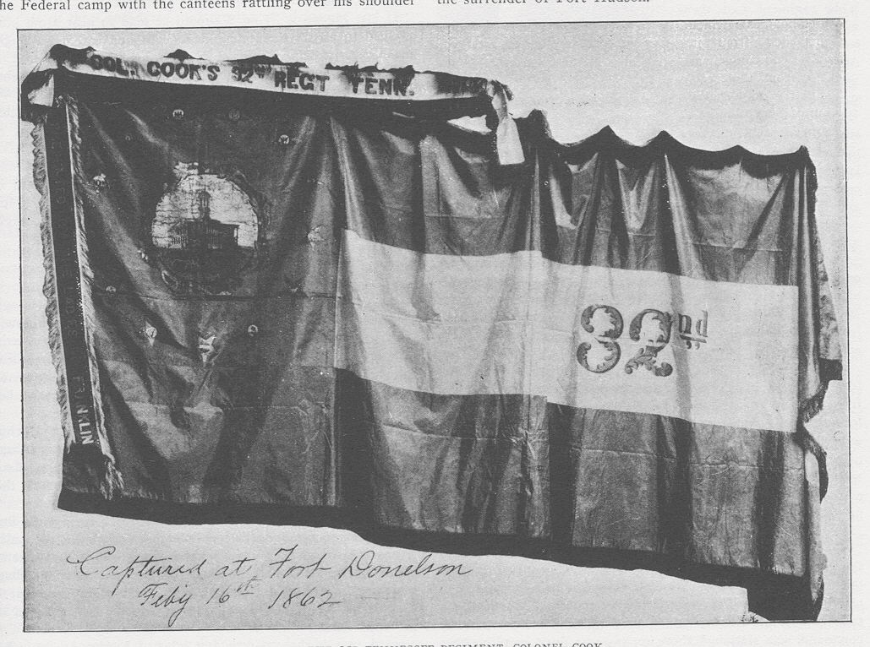 The above engraving is from a photograph (by Giers, Nashville) of the flag indicated, Thirty-Second Tennessee. It is doubtless the finest Confederate banner now in existence that was carried through a battle. The VETERAN thanks W. T. Rogers, of Chattanooga, Tenn., who (while looking after the interests of the Nashville, Chattanooga, and St. Louis Railway in Ohio) learned from Mr. Theodore C. Lindsey, conducting a loan and brokerage business, in Dayton, O., that he had furnished an old soldier some money, holding the flag as collateral for the loan. After going to the Soldiers' Home at Marion, O., this Union veteran wrote Mr. Lindsey to dispose of it. The VETERAN had engraved on the picture: "Captured at Fort Donelson February 16, 1862." It would have been better to have engraved "surrendered" instead of "captured." Members of that regiment who know are requested to furnish information concerning the flag. It is expected that this beautiful emblem of the stars and bars will be enjoyed by thousands at the Atlanta reunion.

VI, 8, August 1898, p. 383:

Maj. Caloway G. Tucker, of the Thirty-Second Tennessee Regiment, saw the beautiful flag illustrated in the July VETERAN at the VETERAN office, Atlanta reunion, and he states the regiment used a small flag during the battle, and that this fine one was folded and standing in Col. Cook's tent when the surrender occurred. The man who placed it in the pawn shop at Dayton, Ohio, testified falsely in stating that it was captured in a charge. That gallant [Thirty-Second Tennessee] regiment drove everything before it in the battle, that of Fort Donelson.

VI, 9, September 1898, p. 416:

W. H. Doggett, Hamilton, Tex.: "I see that the long lost flag of the Thirty-Second Tennessee, Ed. C. Cook's Regiment of Volunteers, has been found. I, for one, say that flag was never captured at Fort Donelson. The morning of the surrender Col. Cook folded the flag tightly and put it in his valise, and kept it there while in prison. When he started South to be exchanged a wagon took his valise, with other baggage, to the train, and the Colonel found that his valise had been opened and the flag was gone. That was some eight months after Donelson fell. Mrs. Ed C. Cook and other ladies of Franklin, Tenn., presented that beautiful banner with its bright starts to our regiment, and we were all proud of it and of our noble colonel, as well as all of our officers; there were gallant and true.

VI, 11, November 1898, p. 537:

ESCAPES FROM PRISON—FLAG OF 32d TENN.

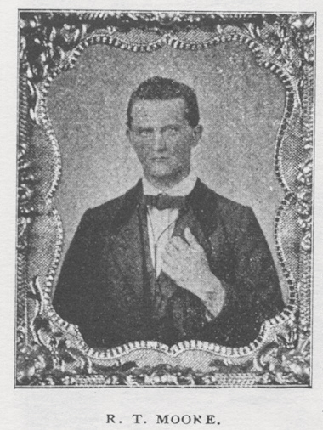
R. T. Moore writes from Tullahoma, Tenn.:
The flag of the Thirty-Second Tennessee was presented to the regiment by the ladies of Franklin while we were camped at Bowling Green, Ky. It was carried by me with the regiment to Russellville, and then via Clarksville to Fort Donelson, and into the fight on the hill outside of the works on Saturday morning, February 15, 1862, when we were ordered to capture a battery that was severe upon us with shot and shell; but we failed to take it.
Some think that the blue flag only was carried into the fight in the woods on the hill, but this same flag was with the regiment until it surrendered, February 16, Sunday morning. When it was known that we were prisoners, or soon would be, I pulled the flag off its nice cedar staff, rolled it up, and put it on my bosom, where I kept it concealed for several days. While on the Ohio River, just before reaching Cairo, Col. Cook, having learned that I had it, asked for it, whereupon I delivered it to him. The flag was never captured nor surrendered, but I am told that it was stolen from Col. Cook. The history of how Mr. [S. A.] Cunningham, editor of the VETERAN [and late of the 41st Tennessee Infantry], procured it from a pawn broker in Ohio is know to its readers.
After landing at Cairo the commissioned officers were separated from the noncommissioned officers and privates, and we (the latter) were taken first to Lafayette, Ind., kept there about four weeks, and then taken to Camp Morton, Indianapolis.
On the night of July 13, 1862, J. H. Harrelson, of the Forty-First, and R. M. Franklin and I, of the Thirty-Second Tennessee Regiments, scaled the tall plank fence during a downpour of rain. However, the guards saw and shot at us. The rain drowned the noise we made in climbing the wall and in jumping to the ground, and that allowed us to get well under way before the guards discovered us. The "halt!" rank out and bullets whistled, one of them passing close to my head. After running across an opening and away from the light, we ran through a cabbage patch, which was ankle deep in mud and water from the rain. Harrelson fell over a large cabbage head, and I tumbled over him. Franklin thought we were both shot. You may imagine how we suffered with cold after running ourselves down. We were all perfectly wet; even the matches were too wet to burn. We went out about five miles on the Cincinnati railroad, and, after concealing ourselves in a brier thicket, we huddled together like little chickens to keep warm.
About eight or nine o'clock, to our great joy, the sun came out, and soon warmed us. We got some sheaves of wheat from a field near by, which served for beds and food. At night we went back to the city, arriving there in time to get a lunch before train time. Having purchased tickets, we boarded a northbound train at 10:20 P. M., July 14, and started for Canada, passing out of plain view of the lights in Camp Morton. To avoid suspicion, we bought tickets to local stations en route. On July 16, at about 2 P. M., we reached the "promised land," having safely crossed the Detroit River and landed in the flourishing town of Windsor, Ontario. We crossed in a skiff rowed by one Mr. Cunningham. There we were under the British flag. True, we were far from home, but were free from guards with guns and bayonets, and free to work or starve, for we were without a dollar in the world and our clothes were nearly worn out. Mr. Franklin had a sister in Pennsylvania, who, with her husband, Mr. McEntyre, visited him soon after our arrival. I hired out to do farm work a couple of months, during which time I engaged to teach a country school. The next three years I taught in the village, or town, or Leamington, and courted the girls and had a good time generally. What changes! I married in December, 1865, and came back to Tennessee in 1867. [R. M.] Franklin lives at Mt. Dora, Fla., while [J. H.] Harrelson is somewhere in Texas, if living. He left Canada in January, 1863, and worked his way through the Federal lines and joined a Capt. Gray, near Fort Donelson.

VII, 11, November 1899, p. 484:

FLAG PRESENTED BY LADIES OF FRANKLIN.

An interesting relic will be exhibited at Franklin when the Confederate Monument is dedicated, November 30 [1899]. No more fitting relic of the war may be anticipated by those noble women than the exhibition of the flag of the Thirty-Second Tennessee Infantry. It was presented to the regiment, largely raised and recruited from Williamson County, of which Franklin is the county seat. The streamers indicate "Col. Cook's Thirty-Second Regiment, Tennessee," and "Presented by the Ladies of Franklin."
This flag was found by accident in the hands of Mr. Theo. C. Lindsey, a Union veteran at Dayton, Ohio, who held it as collateral, and the treasure was procured from him. It is doubtless the finest flag that was ever borne by a Confederate ensign in service. A photo engraving of this magnificent banner appears on the title-page of the VETERAN for July, 1898.
R. T. Moore writes from Tullahoma, Tenn., that "the flag was presented to the regiment while we were camped at Bowling Green, Ky. It was carried by me with the regiment to Russellville, and then via Clarksville to Fort Donelson, and into the fight on the hill outside of the works on Saturday morning, February 15, 1862, when we were ordered to capture a battery that was severe upon us with shot and shell; but we failed to take it. Some think that the blue flag only was carried into the fight in the woods on the hill, but this same flag was with the regiment until it surrendered, February 16, Sunday morning. When it was known that we were prisoners, or soon would be, I pulled the flag off its nice cedar staff, rolled it up, and put it on my bosom, where I kept it concealed for several days. While on the Ohio River, just before reaching Cairo, Col. Cook, having learned that I had it, asked for it, whereupon I delivered it to him. The flag was never captured nor surrendered, but I am told that it was stolen from Col. Cook."
Mr. [Ed. C.] Coook wrote from Franklin, November 16, [1899,] concerning the flag: "Col. Cook told me he had the flag taken from the staff at the surrender of Fort Donelson and put it with his clothes, thinking it would be safe; but he lost both on the way to Fort Warren [Massachusetts,] somewhere between St. Louis and the prison.... The white stripe [of the flag] was not of my wedding dress. The material was all new and bought especially for this flag. I have never seen it since it was made. So far as I know, I am the only one now living who helped to make it."
In connection with the monument dedication at Franklin, Mr. J. W. Baugh writes for the Williamson County News: "And now my pen falters in the feeble attempt to pay tribute to Williamson's soldiery and her fallen heroes. On every battlefield, from Palo Alto to Resaca de la Palma, and from Sumter to Appomattox, the soil has been drenched with the blood of martyred heroes. The soil is consecrated ground; it is besprinkled with the blood of human sacrifice. Many of the early settlers were volunteers of the Revolution and in the various wars and engagements with the Indians, from the earliest settlements to their final expulsion, from the war of 1812, the Mexican war, the civil war, the Spanish-American war, and the Phillipine war have all been recruited largely by volunteers from her borders."

VIII, 1, January 1900, p. 15:

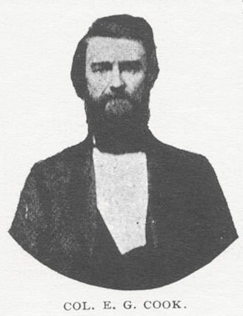
An event that deserves record in connection with the dedication of the monument at Franklin [Tennessee] was the exhibition of a flag seen there that day for the first time since it was sent to Col. Ed Cook's Thirty-Second Tennessee, put by Col. Cook in his valise at the surrender of Fort Donelson, but stolen, and recovered two years ago through a pawn shop in Ohio. Mrs. Cook is the only person known to be living who participated in making it. This flag was secured to the shaft of the monument under the veil, and when the latter was removed it floated to the breeze, as pretty a banner as was ever carried by heroes of any army.
United States Senator W. B. Bate was expected to attend the ceremony, but instead sent this telegram to Mrs. Richardson, President of the Chapter:
"I am sorrow-stricken because I cannot be with you to-day. My heart is with you in the fullness of its love for the dead and living heroes who as patriots fought for our Confederate cause as never men fought before or since. God bless the old gray coat and all who wore it!"
[Image of Confederate Monument at Franklin, Tenn.]

IX, 6, June 1901, p. 276

FRANK DAVIS.

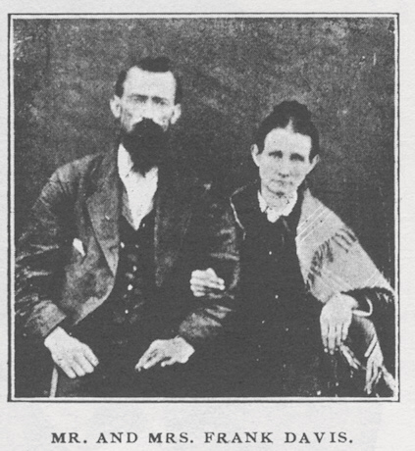
A. A. Ezell, Pulaski, Tenn., writes of comrade who died about a year since:
Frank Davis was a member of Captain. [Caloway G.] Tucker's Company, Thirty-Second Tennessee Regiment. He enlisted in 1861, and was with the Regiment until the battle of Chickamauga, where he lost a leg, but even after being crippled he was always ready to do anything for the Southern cause. Many a Confederate scout was fed by him in Marshall County [Tennessee]. Like Sam Davis, he would have died before he would have betrayed a friend. He said of himself: "I was not a soldier—was only fifteen—but tried to be one. A good many Federal horses left Pulaski and were ridden to Dixie by Southern soldiers, and a boy was accused of being instrumental in such flights—but let bygones be bygones. I worshiped the cause of our Southland then, and I love it to-day." Mrs. Davis, his wife, is a faithful and true Confederate.

X, 1, January 1902, p. 5-6:

REGIMENTAL HISTORIES—THEIR IMPORTANCE.

The importance of regimental histories is such that it behooves every veteran soldier to contribute thereto. Commanders of regiments, if living, should be diligent to prepare a record. The surviving officer of highest rank, if only a captain, might secure the cooperation of officers and men from the various companies and divide the work so a history might be secured which would be of inestimable value to the future.
The inspiration to this duty would come to many a veteran if he could read the diary of Col. J. P. McGuire, of the Thirty-Second Tennessee Regiment. He deferred the work for many years, but was spared to write at his convenience for diary and other data the history of his regiment from the beginning to the end. It is a valuable heritage to his children—Mr. Neil and Mrs. Corson—and will every be, when published, an interesting story for those who served in that command, and a credit to Tennessee.
This record shows that Col. McGuire was promoted from major over Lieut. Col. W. P. O'Neal, one of the finest men in all history, who had been in ill health, and wrote the Secretary of War that he waived his seniority of rank, and requested that Maj. McGuire be advanced to colonel of the regiment. A pleasant recollection of the editor of the VETERAN is that of being with these two officers at their last meeting on earth, and just before Col. O'Neal's death.

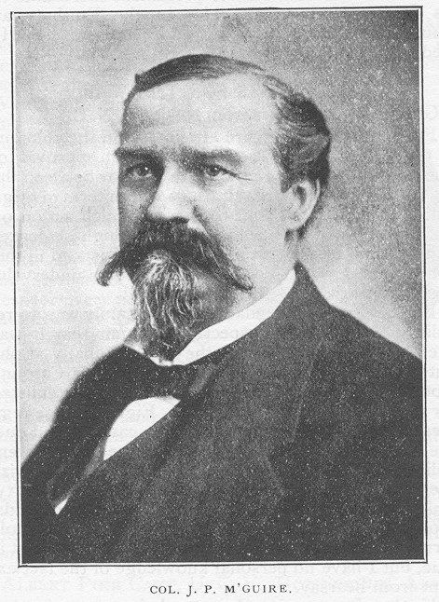

[Circa 1885 Image of Col. J. P. M'Guire]

The record referred to, made by Col. McGuire, contains the letter from the Secretary of War, James A. Seddon, notifying him that President Davis had appointed him colonel. Then there is other correspondence in his behalf at the reorganization of the army by Gens. J. B. Palmer, John C. Brown, W. B. Bate, C. L. Stevenson, S. D. Lee, D. H. Hill, W. J. Hardee, and J. E. Johnston, all in high praise. The testimony is that of Gen. Palmer approved by the others, which is, in part, as follows: He commanded one of the largest regiments in Palmer's Brigade; that in a number of severe battles[,] heavy skirmishes, and in remarkably trying marches he evinced the highest qualities of the man, officer, and soldier. In the drill discipline and general management of troops he had few equals and no superiors. Gen. Brown regarded his [subordinate] as "one of the very best officers in our army." Gen. S. D. Lee mentioned him as one of the most gallant and efficient officers in the army. Gen. D. H. Hill mentiones that he led the skirmishes of Lee's Corps temporarily in his command in the battle of Bentonville, N. C., and "was distinguished on that occasion for gallantry and efficiency." Gen. Bate stated: "No colonel in our army has a better reputation for gallantry and efficeincy [sic]." Gen. Hardee cordially indorsed all the foregoing concerning his gallantry and efficiency as a soldier, and Gen. J. E. Johnston wrote, in conclusion: "Col. McGuire has won a very high reputation in the Army of Tennessee, which fully justifies the preceding reputations, which fully indorse."
Col. McGuire was born in Lincoln County, Tenn., January 23, 1833. After the war he engaged in merchandizing for some years at Pulaski, and later he established a wholesale business at Nashville, and speedily became one of the most prominent merchants in his State. He was an elder in the Presbyterian Church and active in Y. M. C. A. enterprises. He died at Nashville, October 12, 1888.

X, 9, September 1902, p. 418:

G. E. COOK.

George E. Cook died at his home near Pulaski, Tenn., April 18, 1902, aged sixty-five years. He was a kind husband and a devoted father.
Comrade Cook enlisted as a private in Company B, Thirty-Second Tennessee Regiment. He first went to Camp Trousdale, but took the measles, and was brought home unable for service. His regiment was captured at Fort Donelson, and sent to Indianapolis. He then went to Corinth, Miss., joined the Fifth Tennessee Regiment, and was in the battle of Shelton Hill. He was on Bragg's Kentucky campaign; took part, and was in the battle of Richmond, Ky., under Kirby Smith. He rejoined his [old Thirty-Second] regiment at Murfreesboro after they came out of prison, and was promoted to First Lieutenant in 1863. He was with Bragg on his retreat to Chattanooga, Missionary Ridge, and Resaca, where he was severely wounded. When able for duty, he rejoined his regiment, and remained with it until the surrender at Greensboro, N. C. He was a soldier of the highest type, and served his cause faithfully.

XI, 2, February 1903, p. 58-59

THOSE NOBLE ALABAMA WOMEN.

Joe H. Bowman, who was of Company D, Thirty-Second Tennessee Regiment:
"In the October [1902] VETERAN (page 459) appears a tribute by Mrs. Sue Pierce Finely, of Montgomery [Ala.], to Mrs. John May Pierce and her daughter-in-law, Mrs. Mildred Pierce, in regard to the hospital established and maintained in Collirene, Ala., during the year 1864. As one of the boys in gray who was an inmate of their splendidly conducted home, I add my tribute to the memory of those patriotic people who so kindly ministered to our wants and nursed us through our afflictions. I say home instead of hospital; for, had we been their sons or brothers, they could not have cared more kindly for us. When we arrived in Montgomery, June 24 [1864], we found every hospital in the city full, and we were sent to a hospital tent on the banks of the Alabama River on an outskirt of the city, where we fought mosquitoes at night and hid from the blistering sun during the day. About the last days of the month some twenty-five or thirty of us were lined up and marched down to the wharf and took passage on a boat, to go we knew not where, but were told that we were going to the country. About daylight next morning we got off at Benton, where Mr. Robert P. Rives met us with vehicles, and after a ten-mile drive we landed at beautiful Collirene, and such a welcome as we received! It seemed as if the whole country had turned out to bid us welcome. On the balcony of the second story (of what was for the time to be our home) were congregated some fifteen or twenty young ladies to see the soldier boys. The old men and elderly ladies met us at the gate to bid us welcome. We were escorted to the house, and after washing our hands and faces, were invited to breakfast; and now, after a lapse of thirty-eight years I can remember how that crowd of soldiers relished that home breakfast. After breakfast those whose wounds the ladies would dress were invited upstairs. I was among the number. At the head of the steps I was met by Mrs. Mildred Pierce, who asked me if she might dress my wound. As kindly and gently as if I had been her own brother she removed the coarse domestic, which was the best our government could furnish. After tenderly washing my wound, she bound it up with nice, soft cloths, and from that day, as long as I was in the community, she was in deed and in truth as kind to me as a sister. As Mrs. Finley says, Mrs. John Pierce furnished the house and her brothers, Dr. James Dunklin and Thomas Dunklin; her sister, Mrs. Caroline Caffey; their mother, Mrs. Anna Dunklin (then in her seventy-sixth year), Mr. Robert Rives, Dr. Peoples, Mr. Wilson,—in fact, the whole community—united in furnishing the supplies to maintain the home. The Mesdames Pierce, Thomas Dunklin, and Caffey served week about as matron [sic]. The Misses Dunlin, Caffey, and Rivers served during the day as nurses. Then, last, but by no means least, big-hearted, whole-souled Dr. Clay Dunklin gave his services as surgeon. How gentle and kind he was, this writer well remembers, for he was for more than three months under his care.
Only one soldier of all those who were sent to Collirene died there—of consumption, brought on by exposure. Some of the soldiers were taken to the homes of citizens who lived a few miles distant from Collirene. But those who lived in and around the hamlet preferred to maintain the home; so the most of us, to give as little trouble as possible to our benefactors, remained at home until ready to return to the front. Mrs. Robert Rives was crippled in a runaway accident about the time we were being carried to the home, and could not do much; but her husband and daughters did their full share. The young ladies of the neighborhood seemed to try to see who could do most to alleviate suffering, and whenever any of the boys were ready to return to the front they were always furnished with a good supply of home-knit socks.
Now, all of those who were past middle age when it was the fortune of the soldier boys to be their charges have crossed over the river. The motto of those good people was truly a Christlike one: "Do as you would be done by." Now that their descendants are scattered from Massachusetts to Texas, my prayer has ever been that the bread their parents cast upon the waters may return to them, and the same kindness that was extended to the boys in gray may be theirs, should they ever need help.
It has been my privilege as well as my pleasure to have as the guest of my family some of the citizens of Collirene and their children several times since the war, and I never hear of their prosperity or that of their children that I do not rejoice.

XI, 3, March 1903, p. 124:

Comrade T. W. Crenshaw, of Woodland Mills, Tenn., died suddenly on January 15 [1903], aged seventy-one years. He served in Company D, of the Thirty-Third Tennessee Regiment of Infantry. A widow, son, and daughter survive him. His regiment may have been the Thirty-Second Tennessee.—ED.

XI, 9, September 1903, p. 398-399:

[Article describes the unveiling of a life-size portrait of Gen. Nathan Bedford Forrest in the State Capitol, Nashville, Tenn.]***At the conclusion of [former Forrest chief of artillery] Capt. [John W.] Morton's remarks, Mrs. Lulu Epperson, the gifted and beautiful daughter of a gallant Confederate soldier, drew the cords of the Confederate flag which covered the portrait—the flag of the Thirty-Second Tennessee stolen at Fort Donelson and secured from a pawn shop in Ohio when the life-sized figure and martial features of the great cavalry general [Forrest] were revealed in vivid colors and the audience burst into enthusiastic applause.

XI, 11, November 1903, p. 506:

IN ENEMY'S LINES WITH PRISONERS.

By T. J. Corn, Estill Springs, Tenn.

I was fourth sergeant in Company K, Thirty-Second Tennessee Infantry, Col. Ed. Cook's regiment, of Gen. John C. Brown's old brigade, then commanded by Gen. J. B. Palmer, under Col. J. P. McGuire.
On the 18th of March, 1865, while camped at Smithfield, N. C., we received orders to cook three days' rations and be ready to move by one o'clock. We marched about sixteen miles in a southeastern direction and camped for the night. We were not permitted to light fires or to make any noise. This was the only indication that we were near the enemy, but at the first streak of daylight a roar of guns in our front told us that the fight was on. We quickly formed and moved by the right flank through the woods into an old field, which we were crossing in quick time when "Old Jo," as the boys loved to call Gen. Johnston, dashed by us going to the front. Although we had been instructed to make no noise, the boys gave him a cheer. He lifted his hat, but did not halt or speak. The Yankees, however, answered the cheer with a few shells, but they did no damage.
On reaching the timber on the far side of the field we formed in line of battle, and, after halting a few moments, were ordered to throw up breastworks. With two or three old axes we cut some pine poles, and with our bayonets dug a little trench, making rifle pits some eight or ten inches high. We were sitting or lounging about when Col. McGuire came walking leisurely by down the line and said: "Boys, you remember the 19th and 20th of September, 1863, at Chickamauga? Well, this is the 19th of March, and you may look out for some work to-day as hot as it was there." He had scarcely finished speaking when a heavy fire opened on our skirmishers in front. They fell back rapidly, closely followed by a brigade of the enemy, who now began to move slowly and in splendid order. Col. McGuire was standing close behind our lines, and ordered us to wait for the command to fire. We were lying down behind our little breastworks in the brush, and the Yankees were within forty steps of us when the order came to fire. It demoralized them completely, and we were ordered to charge. We went at them and drove them over and beyond their works some two hundred yards, capturing all their knapsacks, shovels, picks, etc. After halting long enough to re-form our lines, Gen. Palmer ordered us forward. We struck them next time on their flank, and captured a second line of works. We evidently broke their line in this last charge, for they fell back right and left, and we passed through on a half wheel to the left.
I was on the extreme right of our line, which threw me far inside of the Yankee lines. We were halted a moment to re-form, and I knew from the heavy firing in our rear that the Yanks were making a desperate effort to reëstablish their line; and if they did so, we, especially those of us on our right, were in a ticklish place. I looked to the left of our line, and saw Gen. Palmer sitting on his horse directing the fire on the enemy in front of our left, and just at that time the Yankees came up on his rear and opened on him. It was more than our boys could stand, and they broke in disorder, running to the left. I started out by the same route, but the Yanks closed in behind them solid with their line re-formed, and, after firing a few scattering shots in our direction, went in pursuit. I saw all of this before I dodged behind a tree. The firing grew farther and father away before I ventured out to look around. Not a living soul could I see. I was thinking what was best to do when I heard some one call me. I looked around in the direction from whence the voice came, and saw Col. Searcy, of the Forty-Fifth Tennessee, step from behind a tree, and I never in my life was so glad to see any one. I went to him, and we were discussing the situation, when, to our surprise, our boys began to crawl out from under the brush, logs, etc., until there were seventy-five of us. The Colonel told us the only thing we could do would be to throw away our guns and cartridge boxes to keep the Yankees from getting them; that we were a mile or more inside of their lines, and they were liable to come down upon us at any moment. We had just about decided to do this when he said: "Boys, lets' get back here a little bit on dry land"—the place we were in being a low, marshy spot covered with water. We all moved back together about fifty yards to an old log and halted, when, to our surprise, a Yank crawled out from underneath and said that he would surrender; then another and another. They came from under and behind logs and brush just as we had until there were ten of them, including a Yankee captain, who surrendered his sword to Col. Searcy. They proved to be of the Ninth Indiana, that had become detached from their command in our last assault when we went through their line and made a half wheel to the left. Seeing we had carried everything in front of us, and being cut off from their men, they naturally "took to the brush" and had not seen the last act in the drama. One of them remarked: "Well, Johnnies, you seem to have the earth to-day, and we might as well surrender." Col. Searcy at once realized the situation, ordered us to fall in (after first allowing us to empty the eatables out of the Yankee knapsacks), which we did in single file, two Rebs, then a Yank, until we were all in line, and in this order moved us back into the swamp some two miles or more, and waited for nightfall. Our prisoners never discovered the real situation, but Col. Searcy told them we were going out, quietly if we could, but fight out if we must, and that if it came to a fight they would be the ones most surely to suffer, and advised them to keep quiet and make no attempts to escape or betray us. They accepted the situation, and gave us no trouble. We took a northeast course, keeping concealed in the swamps and dense woodland during the day and taking up our line of march after night. On the 28th of March we arrived at Raleigh and turned our prisoners over to the provost marshal.
I followed the Confederate flag from the beginning to the end of the war, but in all that time never suffered as much from hunger as I did those eight days we were trying to get through the Yankee lines.

XV, 8, August 1907, p. 361-362:

DAYS AND NIGHTS CUT OFF IN SWAMPS.

By W. H. Ogilvie, Allisona, Tenn.

[The experiences of about eighty men of Brown's Brigade, commanded by Gen. J. C. Palmer, in the battle at Bentonville, N. C., has been reported through the VETERAN at different times, but this is a more extensive account. The story recalls the successful experience of the late Col. John H. Anderson, who so far advanced in a charge during the battle of Murfreesboro so as to pass beyond the enemy's line, and yet with these eighty men made his way around to the Confederate army.]
In the Bentonville battle General Palmer's command consisted of the 3d, 18th, 26th, 32d, and 45th Tennessee, the 58th and 60th North Carolina, and 54th Virginia Regiments. They were near the center of the Confederate forces. There was some hard fighting, in which the brigade drove the enemy from his works and advanced a half mile or more. The enemy disappearing in front, it wheeled to the front and attacked the right of the enemy in the rear, the color bearer of the 26th Tennessee with his flag being conspicuously in the lead. Who can tell his name? After fighting about an hour from the enemy's third or rear line of works, a force of the enemy came up in its rear, putting the command in great peril. General Palmer and the greater part of his men made their escape. His horse was shot and, he supposed, killed; but, to his surprise, the animal was soon on its feet and followed him.
The eighty of us who were the last to leave the works were cut off from the only avenue of escape. Finding the enemy all about us in the bushes, we kept dodging them, picking up prisoners three or four at a time until we had twelve to take care of. We marched out to the east with our prisoners, literally surrounded by the enemy and not even hoping to escape. We moved to the right end of their works, and continued in that direction through the swamps nearly knee-deep, passing near their ordnance trains. During the night a lieutenant of the 3d Tennessee, who was wounded severely, walked between two of his comrades until coming to a dry place where some bark had been stripped from the tree, when the gallant fellow asked his supporters to leave him, feeling that he was a burden and that would not escape with him. Seeing a light in the distance, his comrades carried him to it and left him. When they returned, we pursued the march till midnight, not knowing where we were going. Although the enemy's fires were still in front of us, we passed the remainder of the night and the next day on a dry place in the swamp. We could hear the Federals riding about us and talking during the day.
A map of the country taken from the enemy was perused closely, and a plan of action adopted by our officers, Col. Anderson Searcy and Lieut. Col. Alexander Hall, of the 45th Tennessee, Lieutenant Colonel Gurley, of an Alabama Regiment, and Maj. W. H. Joiner, of the 18th Tennessee, besides several company officers. Lieutenant McFadden, of the 45th, and Captain Rhea, of the 3d, with others, took charge of the prisoners. We continued east until we got beyond the enemy, thence south two or three nights' march, thence west, crossing the Alamanche River, and thence north to Raleigh.
About nine o'clock one night a scout reported that we could pass through the enemy's line of fires at a certain point; but when we reached it, we found it impracticable. With bated breath we lay down until another point of escape was reported, which we found not much better, so again we lay down and waited. Our next move was to double-quick down a road between the enemy's fires. On one side we could have greeted them, but didn't regard it an opportune time for exchange of courtesies. On the other side the pine woods were on fire. Our prisoners could have had us captured, but we assured them that the two governments had recently agreed upon an exchange of prisoners and that they would be immediately exchanged; besides, we had also intimated that it would not be safe for them to make known our presence. About midnight, while in a large, open field, with a swollen creek in front of us and the enemy's fires beyond, our strategic colonel, Searcy, nearly despaired of escape. However, we succeeded in crossing the creek and again crossing the road single file in double-quick between camp fires of the enemy. We stopped in a dry, secluded place about daybreak. During the day the enemy drove cattle within one hundred and fifty yards of us. We did not molest them, being content to conceal ourselves and our prisoners behind logs while they passed. Being in need of food, Captain Rhea volunteered to scout for some supplies, and returned with a red "razor-back" North Carolina hog, which he and a comrade had hemmed in a fence corner and cut its throat, being afraid to shoot it. The hog was skinned, divided into ninety-two equal parts, the skin likewise divided, and we devoured all greedily after singeing the hair from the skin.
The next night we moved again in single file, one man behind each prisoner, through swamps more than half of the time and bushes so thick that we would frequently get hung up, occasionally crossing a road. A number of the boys parted with the soles of their shoes. While crossing swollen streams on logs and otherwise some of us occasionally fell in chin-deep.
About the third or fourth morning near daybreak we found a buggy full of meat in the pine woods, which we took charge of and carried to the edge of the swamp, where we put up for the day. Our noble-hearted colonel requested us to take only a pound to the man, saying some good Rebel had hidden it from the Yanks. In returning the meat we found its owner out looking for it, and took him in charge. He claimed to be the best Union man in the country, saying he had hidden out twelve months from the Rebels. He changed front after ascertaining who we were, and informed us that we were on the bank of the Alamanche River right at a crossing place, there being no other nearer than seven miles. It seemed that Providence had guided us. Our captive, though anxious to tell his family good-by, was retained as a guide. We passed over the river before sunset on a log way. Beyond the river we observed wagons passing along the road rapidly, which we supposed to be Yankee wagons, but we did not molest them. Our captive was released after guiding us a night and day, gladly returning to his home.
About the fifth or sixth day out we found a barrel of peas in an old schoolhouse, which we appropriated. Borrowing kettles (about the only thing the community had left, it being along the line of Sherman's march to the sea), we cooked the peas, seasoned with an old goat that was given us, and had a delightful repast. About the 25th or 26th we were delighted by finding an old mill, which we put into use, and, repairing to a beautiful clear spring near the house, cooked and had a greater feast than kings ever enjoyed. The miller was at church, but heard of the depredation and considered forming a posse of fellow-Churchmen and firing upon us; but after investigating the case, he approved our conduct and quieted the "old woman," from whom we had received a severe tongue-lashing. After ascertaining that Lieutenant Colonel Gurley, of Alabama, was a relative, she devoted herself to cooking good things for us. But that dinner—that corn bread dinner! Were I a poet, I would sing its praises. It was a never-to-be-forgotten dinner.
A day or so afterwards we arrived in the vicinity of Raleigh, drew rations, and awaited transportation to our command at Smithfield. At Raleigh we turned over our prisoners, who were loath to leave us. We gave them letters to send to our wives and sweethearts when they should be exchanged, and took the cars, arriving at Smithfield about sundown. The brigade turned out to greet us. General Palmer made a speech in which he declared it to be the greatest feat of the war. Gen. John C. Brown, our former brigade commander, at the time commanding a division, hearing of our safe return, came over to see us and made a speech, in which he compared our actions to Napoleon crossing the Alps and other historical campaigns. Our generals were glad to see us, and under the enthusiasm of the moment spoke too highly of the remarkable expedition. All honor is due to our beloved Colonel Searcy, of the 45th Tennessee, and his counselors, who planned and executed the escape. The private soldiers were intelligent, prudent, and obedient. The prisoners deported themselves well. The North Carolina troops did not go over the enemy's works, though a lieutenant in the 60th North Carolina wrote up the affair in a Raleigh paper, giving too much credit to North Carolina troops. There were only two Alabamians, Lieutenant Colonel Gurley and a private. I have tried in vain to learn the whereabouts of the former. The latter had an article published in the VETERAN a few years ago claiming that the company was composed of Alabamians except a few Tennessee officers. He was in New Mexico.

XVII, 3, March 1909, p. 139:

SURVIVORS OF CONFEDERATE COMPANIES.—John W. Woodard, of Shelbyville, Tenn., refers to the report of Douglas Jarnigan upon Company F, 39th Georgia Regiment, as having from an enrollment of one hundred men twenty survivors, and states: "We can beat that number. Company G of the 32d Tennessee Regiment, commanded by Col. Ed C. Cook until he was killed near Marietta, Ga. [in June 1864], had a total membership of one hundred and twenty, of whom thirty-two are yet living."

XVII, 11, November 1909, p. 567:

EAST.—Thomas J. East was born in 1843 and died at the Old Soldiers' Home in Tennessee in September 1909. In 1861 he enlisted in Company C, 32d Tennessee Infantry. He was wounded and captured at Fort Donelson in February, 1862, and held in prison in Camp Morton [Indianapolis, Ind.] until his exchange in September of that year, when he rejoined his regiment. He was in many of the hottest battles of the war.

XIX, 10, October 1911, p. 490:

DR. MARK W. ALLISON.

Dr. Mark Allison, who had quite rounded out fourscore years of a useful life in the vicinity of his birth, in Bedford County, Tennessee, died September 2, 1911. He enlisted in the Confederate Army, Company G, Thirty-Second Tennessee Regiment, under the gallant Col. Ed. C. Cook on October 15, 1861. He was appointed hospital steward early in service, and was in the surrender of his regiment at Fort Donelson on February 16, 1862. After several months, they were exchanged, and he continued service until again surrendered at Bentonville, N. C.
After returning home, he resumed the practice of medicine and continued it up to within a few months of his death, healing and blessing thousands of men, women, and children. He was a Mason of high degree, a Cumberland Presbyterian, and truly a "Christian gentleman."

XXI, 3, March 1913, p. 124-125:

BROWN'S BRIGADE AT CHICKAMAUGA.

By T. I. Corn, Company K, 32d Tennessee Infantry. [sic: T. J. Corn]

We received battle orders at Lafayette, Ga., and on Friday night, September 18 [1863], we camped on the east bank of the Chickamauga River. About daylight Saturday morning, just after we had waded the river and gotten on the west bank, the enemy discovered our position and opened fire on us, throwing us into some confusion before our line could be formed. As soon as we had recovered, a right flank movement was ordered, and our column was marched in a northwest direction, with General Stewart and General Brown.
When we had gone about a hundred and fifty yards, we were halted. Captain Carns came from the front and reported that all his men were killed and his guns captured. General Stewart then ordered General Brown to retake the guns, and we began a rapid advance. The ground was open, but the enemy was in the woods. The battle was now on in dead earnest, and it was like a cyclone of fire.
Our advance was stead, but the enemy made a stubborn defense. However, when we got in close range, our fire was too much for them, and all that did not run were either killed or wounded. The dead and dying of both sides covered the ground.
In this action General Brown was unhorsed by grapeshot. We lost many artillery horses in this fight. I saw thirteen dead in one pile. The Confederates set the woods on fire while the battle was on, which, with the shouts of the men, the boom of the cannon, and the roar of small arms, was an event never to be forgotten.
Brown's Brigade was made up of the 3d, 18th, 32d, 45th, and 26th Tennessee Regiments [as well as Newman's 23d Tennessee Battalion].
On the Saturday preceding the memorable Sunday of September 20, 1863, just at sundown, Brown's Brigade was moved up close to the enemy's lines and the men ordered to lie on their arms. By midnight the temperature had fallen low enough to bring a light frost; and some of the men, getting very chilly, stirred up some smoldering logs. The flames flashed out suddenly and showed the enemy our position and brought on us an alarming fire of artillery and small arms, knocking the limbs from the trees about us and causing no little excitement. General Brown rushed to the front and gave us a reprimand severe enough to settle the matter of having a fire for the rest of the night.
We held to our arms through the hours that followed, expecting an attack at any minute. The enemy were very near. We could hear them at work building breastworks of the fallen trees and brush, and it did not give us a very comfortable feeling as to the troubles we would have to contend with on the morrow.
We were ordered to assault the enemy about sunrise. Just as we began the advance our provisions for the day came and were unloaded on the ground right behind us. We had time for only a look and had nothing to eat that day. I mention this only to show something of what war is. We had barely gotten out of sight of our rations when we were in deadly conflict with the enemy. Our men advance rapidly, and were soon close in front of a battery which was sowing grape and shrapnel among us like a farmer sows his wheat. When we had gotten so close to the guns that I was sure we would have them in a few seconds, the solid earth seemed suddenly to sink from under our feet, and I was hurled violently to the ground. A shell had exploded immediately in our front, killing and wounding a number of our men. I was knocked senseless, and when I came to myself I was lying in a ghastly heap of dead and wounded. As my mind became clear, I realized that I had lost my bearings and that my regiment was nowhere in sight. My senses told me that I had better leave, and I did not go in the direction of the firing, either.
I found my command some distance in the rear and joined the brigade as it moved to the right and formed in front of the enemy's center, their lines being somewhat in the shape of a horseshoe. We struck this center with a vim that cut the lines in two and threw about four thousand prisoners into our hands. The enemy fell back from the center all the way to their extreme right. This was about noon, and from that time on the battle raged with great fierceness until the rout came.
My regiment, the 32d Tennessee, was ordered forward to support a battery that was in an open field about two hundred yards in front of the enemy's lines. We were formed just behind the guns and were ordered to lie down in a cornfield; and as the corn was too small to hid us, as many as could lay in between the ridges.
The artillery duel between the two forces was fearful, and no less terrible was the continuous roll of small arms. The enemy had taken fence rails and had made a long line of breastworks, and both infantry and artillery were fighting from behind this defense. Finally we dismounted several of their guns and set the rails on fire. Our troops on the right made a direct move, and the enemy's rout was soon complete. In all that awful war I never saw such hasty and headlong flight from a battle field as this. By the sunset the battle was over.

XXII, 2, February 1914, p. 111:

[Image of 32d Tennessee "FN" flag – same as shown above]

FLAG OF THE 32D TENNESSEE REGIMENT, COLONEL COOK.

This beautiful old flag has been lost or stolen. Any information leading to its recovery will be appreciated. It has been exhibited at many Reunions, U. C. V., since coming into the possession of the late editor of the VETERAN, in 1898, and sometimes loaned to others on special occasions. Some one has doubtless forgotten to return it.

XXIII, 10, October 1915, p. front page:

[Image of 32d Tennessee "FN" flag – same as shown above]

FLAG OF THE 32D TENNESSEE REGIMENT, COLONEL COOK.

This handsome old flag, rescued from a pawnshop in Dayton, Ohio, at the instance [sic] of the late editor of the VETERAN, by whom it was sometimes loaned for display on special occasions, has been missing for several years. Any information on it will be highly appreciated. Those who have seen it at any time within the past four years will confer a favor by writing to the VETERAN.

XXIV, 8, August 1916, p. 367:

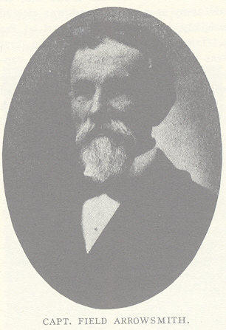
"The battle's o'er, the victory won," and in the peace and quiet of Maplewood is laid to rest all this is earthly of our friend and comrade, Field Arrowsmith. He was born in Giles County, Tenn., on July 7, 1839, he lived beyond the allotted span, and in the fullness of years well spent in the service of his Master and his country he "fell on sleep" at midnight, April 30, 1916. As gentle and pure as a woman in thought and act, an exemplar of righteous living, a citizen of blameless character, a Christian without dissimulation, and a soldier of the Southern arms who bared his breast to the storms for four long years without fear or faltering is the epitome of his life. Truly the "gentlest are the bravest." Enlisting as a private in Company B, 32nd Tennessee Infantry, in 1861, he was made orderly sergeant of the company; was captured at Fort Donelson in February, 1862; exchanged September 1862; wounded at Chickamauga in September, 1863, and again at Powder Springs in June, 1864. He was elected captain of his company after the battle of Chickamauga. At the reorganization of the army in North Carolina, in 1865, the 32d was consolidated into one company, of which he was elected captain, and assigned to the Fourth Consolidated Regiment under Colonel Searcy. Paroled at Greensboro, N. C. in April, 1865, he returned to Pulaski, Tenn., where, as one of its leading merchants, he brought to the restoration of his broken fortune and the upbuilding of his ruined country all the energy that, "making no apologies for the past," looked forward with Christian hope and helpfulness to the confirmation of all that was best (in God's good time) in the cause to which he had consecrated the best years of his young manhood.
This is a short sketch of a life that deserves a better history; but the love and devotion of a noble wife, the abiding esteem of his old comrades in arms and of the community in which he lived will hold his memory as a sacred heritage.

XXIV, 12, December 1916, p. 561:

M. R. ROCHELLE.

M. R. Rochelle died at Hohenwald, Tenn., October 6, 1915, at the age of seventy-three years. He was born April 10, 1842, in North Carolina and went to Tennessee with his parents, who settle in Lawrence County, where they remained until the War between the States. Comrade Rochelle then enlisted in the Confederate army, serving in Company C (Davenport's company) 32d Tennessee Regiment, Col. Edward C. Cook [sic], of John C. Brown's brigade. He was taken prisoner at Fort Donelson and was seven months in Camp Morton, at Indianapolis, Ind. He was then exchanged at Vicksburg.
Comrade Rochelle was a member of the Cumberland Presbyterian Church. He was buried with Masonic honors in the cemetery at Hohenwald, Tenn. He lived as became a man and died in full faith of the resurrection. His second wife survives him, with one son, T. J. Rochelle, of Riverside, Tenn., and a daughter, Mrs. M. F. Thompson, of Hohenwald.

XXV, 8, August 1917, p. 386:

W. G. Brashear, of Lawrence, Tenn., belonged to Company D, 32d Tennessee Infantry, and served under Captain Davenport and Col. Ed. C. Cook. He is in need of a pension and would be glad to hear from any surviving member of his company.

XXVI, 6, June 1918, p. 262:

A. N. Crawford.

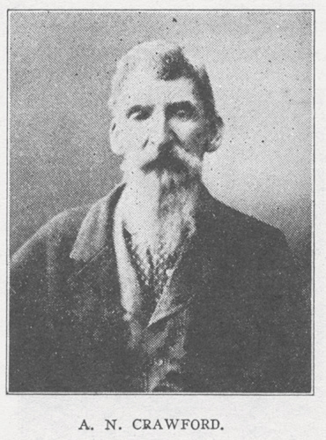
A. N. Crawford died on January 23, 1918, at his home, near Lillard's Mill, aged eighty-four years. He was a son of Dr. Crawford and was born near Farmington, Tenn. His maternal grandfather, George C. Neill, was the first white man to settle at Farmington about the year 1795. When his country called for volunteers, young Crawford was among the first to answer the call, enlisting in Company G, 32d Tennessee Infantry Regiment, which won high honors on many fields of battle. The regiment was captured at Fort Donelson in February 1862, and was sent to Camp Morton, Indiana, remaining in prison until exchanged at Vicksburg, Miss., in 1863 [sic: September 1862], after which it was reorganized from this point and marched to Murfreesboro to take part in that bloody contest [sic: the regiment was deployed at Wartrace, Tenn. during the Murfreesboro engagement and did not participate in it] and next to Chickamauga September 19 and 20, 1863 and in the battle of Resaca, Ga.
Comrade Crawford received a wound which caused the loss of a leg. He bore the name of being one of the bravest and most courageous soldiers who ever marched into battle. After the war he was elected trustee of Marshall County. Later in life he lost an arm from a diseased hand, making him quite a cripple, and for several years had been confined to his bed, but bore his afflictions with cheerfulness, tenderly cared for by his daughter, Miss Ella, during his declining years. Two sons and three daughters survive him.

XXVII, 2, February 1919, p. 47:

[Extracted items from article about an autograph book owned by Lieutenant Colonel W. J. Sowell, 48th Tennessee Infantry]

"Ed C. Cook, Colonel 32d Tennessee Regiment. Surrendered at Fort Donelson February 16, 1862. Address, Franklin, Williamson County, Tenn."

"J. B. Palmer, Colonel commanding 18th Tennessee Regiment. Surrendered at Fort Donelson on February 16, 1862. Address, Murfreesboro, Tenn."

XXVIII, 7, July 1920, p. 269:

[Extract from article discussing 25 April 1920 memorial services for members of Sterling Price Camp, Dallas, Tex., who had died during the previous year]

Capt. W. A. Summers, 32d Tennessee Infantry.

XXIX, 3, March 1921, p. 122:

Mrs. J. C. Brownlow, of Denton, Tex., is very anxious to communicate with any one who knew of the service of her husband, J. C. Brownlow, who enlisted in the service from Pulaski, Tenn., as a member of John Brownlow's company, Colonel Cook's regiment, the 32d Tennessee. He was wounded at Chickamauga and was afterwards in the hospital a long while. He removed to Texas some forty years ago [about 1880]. His wife is bedridden and in need of help. Write to J. M. Gary, 809 North Locust Street, Denton, Tex.

XXIX, 8, August 1921, p. front page:

BOYS OF YESTERDAY.

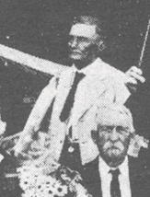
The picture given on this page shows a group of seventeen Confederate veterans assembled at the home of Mrs. Fannie Nunn, at Sweetwater, Tex., on June 26, 1921, to celebrate the 91st birthday anniversary of her father, Lieut. J. W. Wright. An old-time, bounteous Southern dinner was served, and many incidents of the glorious ante-bellum days in the South were related. The thrilling strains of "Money Musk," "Durango's Hornpipe," "Natchez under the Hill," etc., were rendered by a master fiddler and enjoyed by the "boys" of the sixties, bringing to memory many joyous scenes of the long ago. Six of the number present received wounds during the war—one was wounded three times. [J. C. Moore, 32nd Tennessee, is shown standing in a white jacket in the above image extracted from the group photo.]

XXX, 2, February 1922, p. 68:

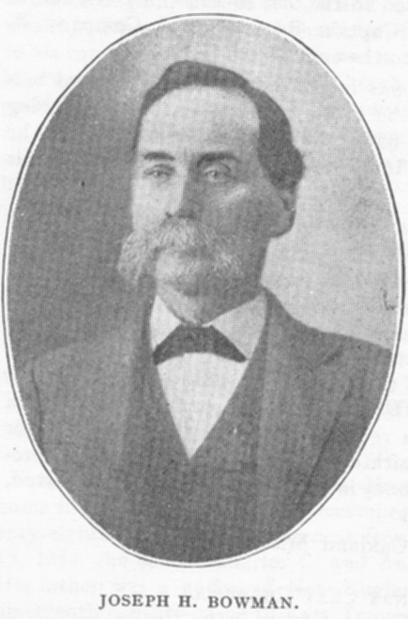
[C. 1900 Image of Joseph H. Bowman]

JOSEPH H. BOWMAN.

Joseph H. Bowman enlisted in Company D, 32d Tennessee Infantry, at Tullahoma, in March, 1863, before he was sixteen years old. He was an ideal soldier from that date to June 22, [1864] when he was badly wounded in the right hand and arm in the battle of Powder Springs Road on the left of the Kenesaw line [sic]; and he had not recovered from the wound when he was paroled on May 17, 1865.
He was married to Miss Jennie Brown, a daughter of one of the prominent families of Williamson County. She and five sons and two daughters survive him, all of whom are honored and respected citizens.
Joe Bowman was honored and loved by all who knew him; he was a high-toned Christian gentleman, and he will be greatly missed by his Church, by his neighbors, and especially by the McEwen Bivouac and Camp at Franklin, of which he had been a member since the organization. He had acceptably filled every [camp and bivouac] office, and at the time of his death was treasurer, which position he had held for many years.
May we remember his many virtues and try to emulate them.

XXXI, 10, October 1923, p. 387:

JAMES M. MOREY.

One of the most loved and highly valued citizens of Greeneville, Tenn., was lost to that community in the death of James M. Morey on August 18 [1923]. He was of New England ancestry, his parents having come South a few years before his birth at Jonesboro, Tenn., in 1844. His father, Rev. Ira Morey, was a Presbyterian preacher at Franklin, Tenn., at the outbreak of the war in 1861, and on account of his strong Union sentiment he was advised to go North, which he did in 1862. "But the boy Jimmie, seventeen years old, strong in the hot-blooded convictions of youth, could not be restrained from casting his lot with his boyhood friends on the side which he firmly believed was right, and that same year he joined the Confederate army. Here is the story of the boy's game as he played it, told in the application blank for the Roll of Honor, C. S. A., in the Confederate Museum at Richmond, Va.:
"James M. Morey, Company D, 32nd Tennessee Infantry.
"When Company D was organized at Franklin, in September, 1861, James M. Morey was too young to be sworn into the service. When the company (which had been captured at Fort Donelson) arrived at Knoxville after exchange, he voluntarily left Franklin and joined the company in October, 1862. From that day to the date of his capture in Orangeburg, S. C., in February, 1865, he never missed a roll call, he was not absent from his command for a single day, nor did he shirk a single duty. He was in every battle in which his regiment was engaged, from Chickamauga and Missionary Ridge down through the Georgia campaign from Dalton to Jonesboro, with Hood in his march to Tennessee and battles around Nashville and then back south. On Christmas Day [1864], at Anthony Hill, Tenn., he was the first man to put his hand on a captured cannon, and captured a horse belonging to an officer to the battery [sic]. In fact, in every engagement he was at the front, and a better, a cooler soldier never fired a gun. For several months he suffered with an abscess upon his leg, and seven out of ten men would have given up; but, although he was urged to do so by his company officers, he refused to go to the hospital, but stayed with his command and performed every duty.
"The above statement is here put upon record by two of his company officers as a matter of justice to a true, tried, and worthy soldier.
"W. W. Courtney, Lieutenant Company D.
"A. P. H. Watson, Sergeant."
From 1865 to 1890 Comrade Morey lived at Malden, Mass., his business interests being in Boston; and in 1868 he was married to Miss Louisa M. Broughton, daughter of Capt. Nicholson Broughton, of Boston. His health breaking down, he returned to Tennessee in 1890 and made his home in Greeneville, where he had lived for a time in boyhood. His dominant characteristic was his religion, which he practiced daily in his life. He was an enthusiastic Presbyterian, and for thirty-two years served as elder in his Church, and for many years was its treasurer, also superintendent of its Sunday school. He was a great student, finding enjoyment in his books and delight in quiet pleasures. All who came under the influence of his genial personality became responsive to the inherent friendliness of his nature, and he made friends wherever known.

XXXIII, 9, September 1925, p. 359:

B. F. Ramey, of Ardmore, Okla., would like to hear from any old comrade of the 4th Georgia Cavalry who can give him any information of a brother who served with that command. This brother (whose name he does not give) enlisted at the beginning of the war and served under Captain Kingsley and Colonel Avery. Comrade Ramey himself served with the 32d Tennessee, Company A, and if any comrades of that command see this, he would be glad to hear from them.

XXXIII, 10, October 1925, p. 365:

WIFE OF COL. E. C. COOK, THIRTY-SECOND TENNESSEE INFANTRY.

On June 23, 1864, [sic] at the battle of Culp's Farm [Kolbs Farm], near Marietta, Ga., Col. Edmund C. Cook, commanding the 32d Tennessee Infantry, and acting brigadier general at the time, received his death wound. Sixty-one years later, on July 4, 1925, his devoted wife, Mrs. Eliza G. Cook, joined in the better land. She died at the tome of her niece, Mrs. Thomas Maslin, in Winston-Salem, N. C. in her eighty-seventh year. Her body was taken back to Tennessee and laid to rest in the cemetery at Franklin.
Mrs. Cook was a daughter of Maj. William Maney, of Revolutionary fame, and was one of a family of thirteen children, born and reared at the old Maney Homestead on the Nashville pike near Franklin. In the McEwen Bivouac at Franklin is the battle flag of Colonel Cook's regiment, which she made from her wedding dress; and in the VETERAN office is the handsome headquarters flag which she and other ladies of Franklin made for Col. Cook, and which was stolen from his baggage when on the way to prison, the flag being found in a pawnshop in Dayton, O., and bought by the late editor of the VETERAN.
One son, Ed Cook, of Carson City, Nevada, survives her, also a brother and one sister.

XXXVI, 8, August 1928, p. 282:

Mrs. M. A. Barnett, 707 North Robinson Street, Oklahoma City, Okla., wishes to hear from anyone who served with her husband, William Barnett in Company G, 32d Tennessee Regiment, or who knew of his service. He enlisted at Franklin, Tenn., in the fall of 1861, and was captured at Fort Donelson, and in prison six months at Camp Morton, Indianapolis; was exchanged at Vicksburg in September, 1862, and later served in General Buckner's Division. Any information will be appreciated.

XXXVII, 1, January 1929, p. 26-27

CAPT. W. W. COURTNEY.

"For distinguished valor and skill on the battle field of Chickamauga" reads the commission which advanced W. W. Courtney to a lieutenantcy in Company D, 32nd Tennessee Regiment, which commissioned was issued by James A. Sedden, Secretary of War, C. S. A., and signed by President Jefferson Davis; and from date of that appointment until he was captured on March 19, 1865, young Courtney had command of skirmishers and reported only to his brigade commander.
Such was the record of this young soldier of Tennessee in the Confederate army, and no less admirable was his record in the days and years since the war in his devotion to the South and his faithfulness to duty in her citizenship. His life record was closed on the 20th of December [1928], after months of illness, and at Franklin, Tenn., the place of his birth and where his long life had been spent, this gallant soldier and Christian gentleman was laid to rest beside the loved wife, whom death had called so shortly before.
Captain Courtney was born in Franklin on November 16, 1842, the sond of Robert and Eliza Courtney, and there he enlisted as a boy of nineteen in 1861, joining Company D, of the 32nd Tennessee Regiment, under Col. Ed Cook. That he served with distinction is shown by his being one of five Tennesseans who were commissioned for bravery in the battle of Chickamauga, and his record also shows participation in the following battles: Fort Donelson, where he was captured and then held in Camp Morton until September, 1862; Murfreesboro (1862); Chickamauga, Lookout Mountain, Missionary Ridge, Rocky Face Ridge, Resaca, Atlanta, Jonesboro, Murfreesboro (1864), and Bentonville, N. C. Official record shows that he was released from prison in June, 1865. He was wounded in an engagement in Alabama, and was in the hospital for forty days.
In late years, Captain Courtney had been active and prominent in the Confederate organization, serving as brigadier general of the Tennessee Division, U. C. V., and he was a member of the State Board of Pensions when he was stricken in August, 1928. For years he served as city judge in Franklin, and in other ways had rendered signal service to his home community. He was one of the most devoted workers in the Southern Methodist Church, and among the oldest members of the F. and A. M. Lodge, which he joined when only twenty-two years of age. He was married in 1868 to Miss Annie Neely, and is survived by two sons and two daughters.
A man of the old school of the South at its best, with the courtliness and charm of the days gone by, Captain Courtney yet kept abreast of the times and contributed an efficient and valuable part to the life of his community and section.

